DATA SET COLLECTION:

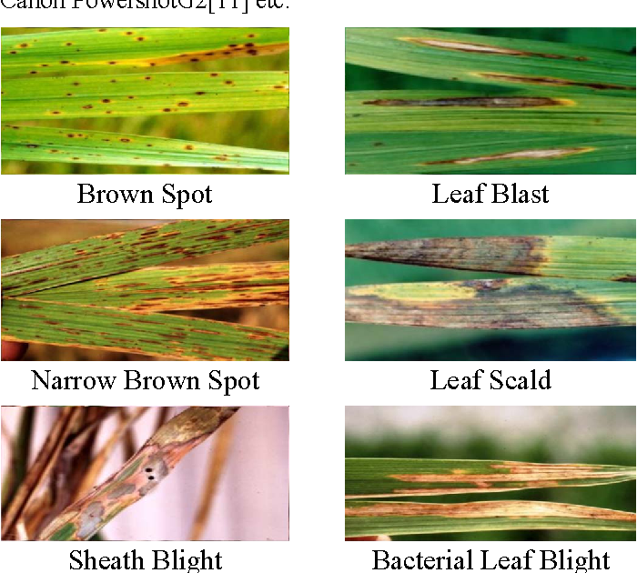

1.TYPES OF DISEASES

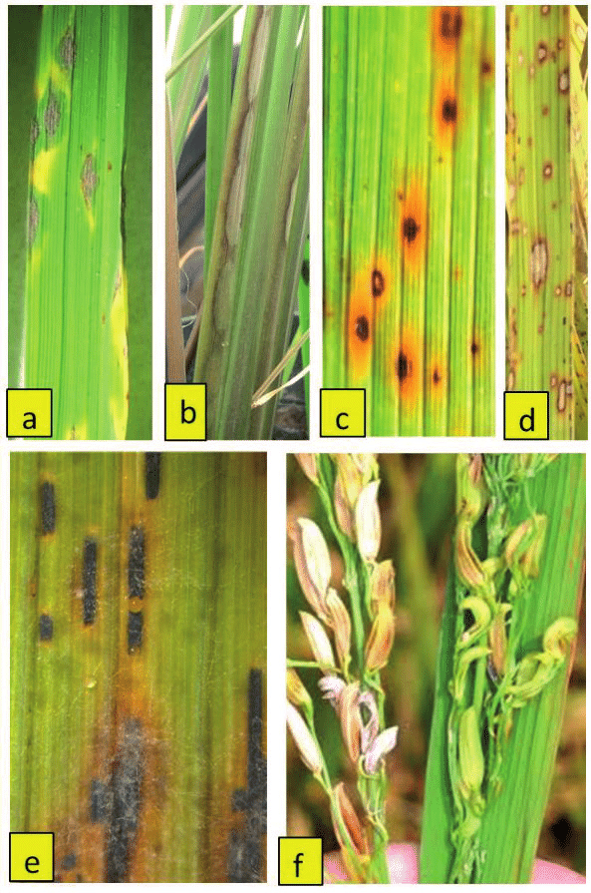

2.OVER ALL DISEASE PREDICTED DATASET